xPlat Azure Command Line Interface (CLI)

The xPlat Azure CLI allows users to manage their Azure cloud resources from non-Windows devices.

The most powerful automation capabilities are offered through Windows-only i.e. through Microsoft Azure PowerShell module, and now we have a cross-platform (xPlat) CLI tool that enables you to perform management tasks from Mac OS X or Linux systems.

The Azure xPlat CLI tool runs on top of the Node.js application framework.

Use an Installer:

* [Windows Installer](go.microsoft.com/?linkid=9828653&clcid=0x409)
* [OS X Installer](go.microsoft.com/fwlink/?LinkId=252249)
* [Linux Installer](go.microsoft.com/fwlink/?linkid=253472)

The Azure xPlat CLI tool interfaces with both the older Azure Service Management (ASM) REST API and the newer Azure Resource Manager (ARM) REST API. You can deploy ARM JSON templates with the xPlat CLI Tool, which enable you to rapidly provision Cloud Resources into a Resource Group.

Install and use Node.js and npm

If Node.js is already installed on your system, use the following command to install the Azure CLI:

|  |
| --- |
| npm install azure-cli -g |

NOTE:

On Linux distributions, you may need to use sudo to successfully run the npm command.

* Install the Node.js application framework. This framework includes a package manager called NPM (Node Package Manager). This framework comes with visual studio installation set up.
* Open Node.js command prompt and type npm install –g azure-cli and press enter.



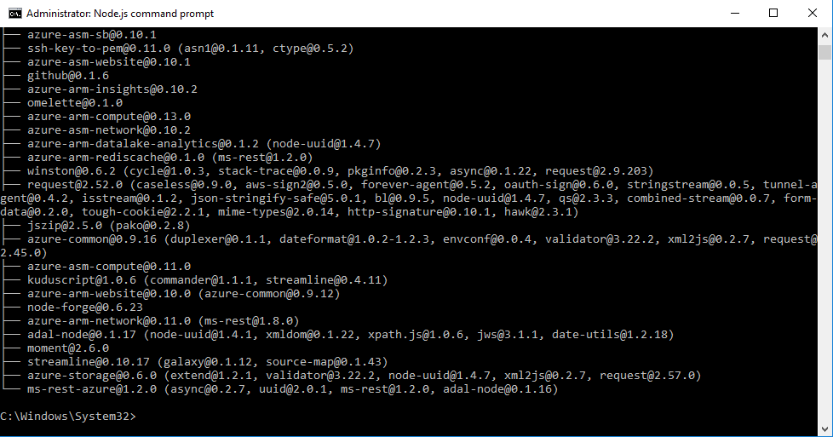

Once the Node.js package installed, you will be able to call it directly from the command line. Just type **azure** in the command prompt. If you see Azure in the command prompt then it is installed successfully.

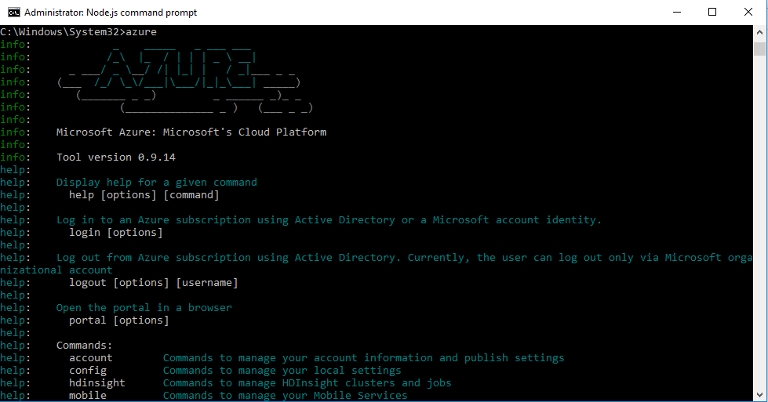

Need to authenticate against Azure using either **Azure Active Directory (AAD) or Microsoft Account** **(MSA)**.

For Authentication, just type **azure login** and then press enter. Then it will give some URL with code, just copy the URL and type the given code in the browser.

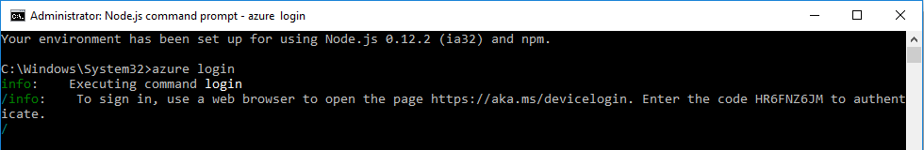

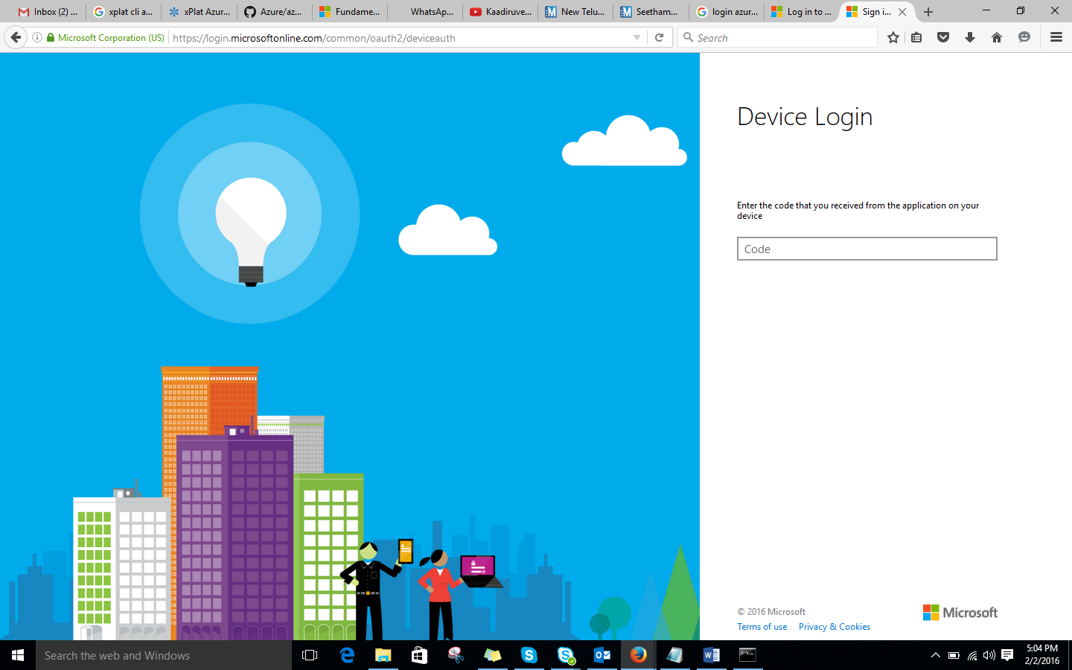

Once you enter the **Device ID** in the textbox it will **redirect** to **login page** where we have to mention the **username** and **password** which has **azure access**. Once the credentials are authenticated the browser will be below:

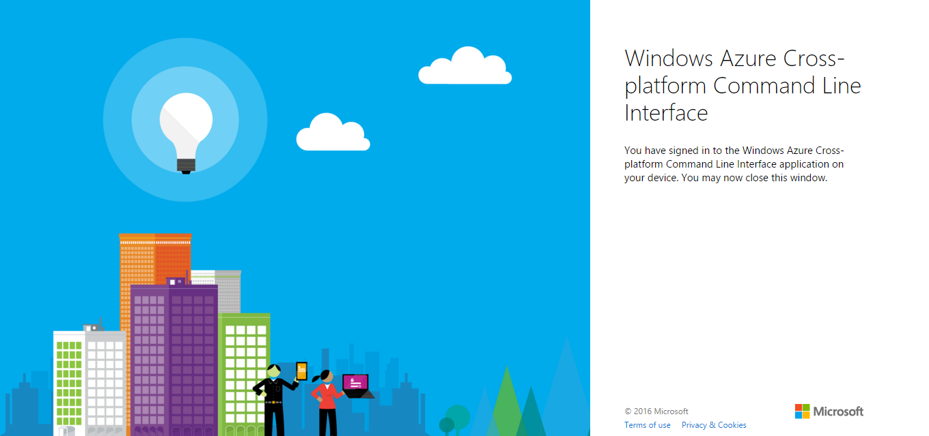

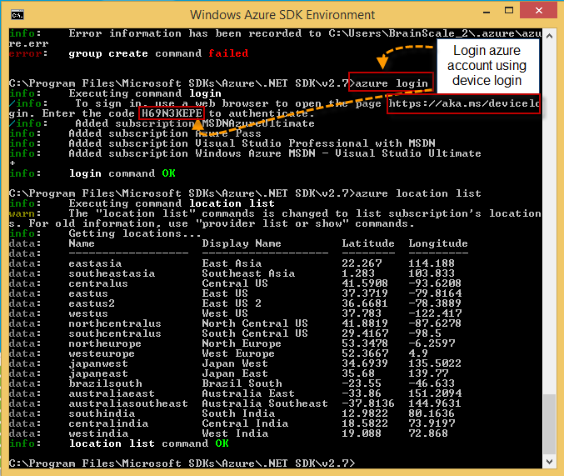

Once you are authenticated then you want to make sure that future commands are operating on the correct subscription. If you have access to more than one Azure subscription, so first you’ll need to select the appropriate subscription. To select type the below command in the command prompt:

C:/> azure account set <subscription-name>

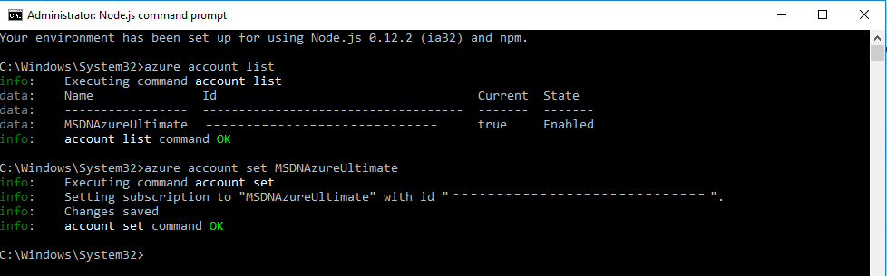

The above command sets one particular subscription to azure CLI so that whichever command you run in CLI will be effective in that particular subscription which is set.

To check the list of subscription Name, you can use the below command:

C:/> azure account list

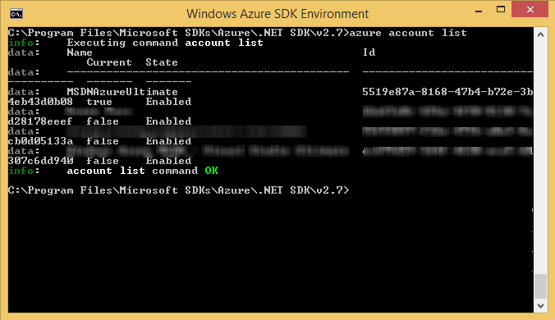

To Log out:

C:/> azure logout –u <email-id>

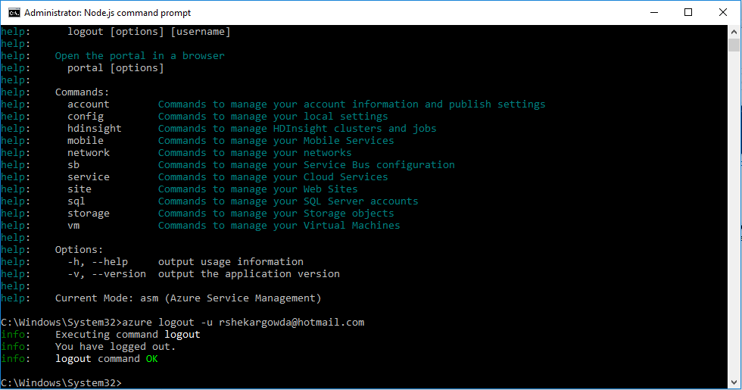

The XPlat CLI includes some pretty extensive built-in help for the various CLI commands and options.  To get help on the list of available commands, you can run:

|  |
| --- |
| azure --help |

To get help on the various actions and options available for each command, simply run the command with the --help option specified at the end of the command line. For example, to see help on creating VM's via the CLI, you could run:

|  |
| --- |
| azure vm –help  ( Or )  azure vm create --help |

You may have noticed in the help ouput that the XPlat CLI includes a --json option to output information in JSON format. This brings us to the next step.

Azure cli has two modes - Service Management Mode and Resource Management Mode. Resource Manager is a relatively recent addition to Azure and it’s available on new portal. It allows you to manage a group of resources as a logical unit. Example - a bunch of servers on SQL Server AlwaysOn setup. There are a bunch of templates available which can be downloaded and modified. At the time of this writing, these two cli modes are exclusive and you can switch between them using commands below

|  |
| --- |
| azure config mode arm  ( Or )  azure config mode asm |

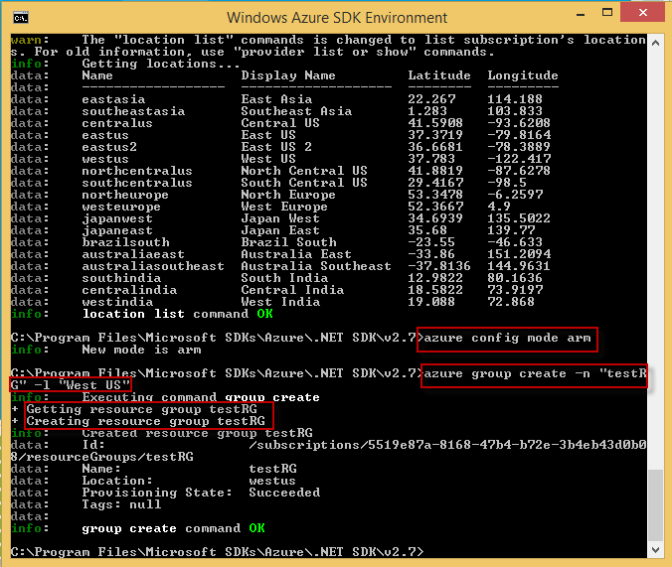

Coming back to service management, following are the major commands available. The commands are easy to construct. They are generally like this

|  |
| --- |
| azure [topic] [verb] [options] |

Check out Azure CLI complete command reference [here](https://azure.microsoft.com/en-us/documentation/articles/virtual-machines-command-line-tools/)

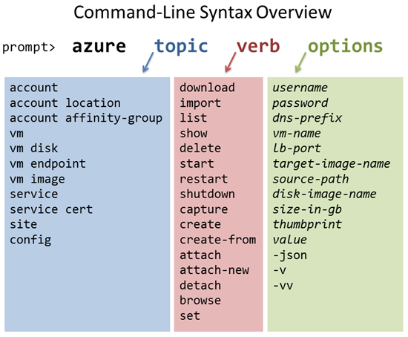

Creating Resource Group:

A resource group is a logical grouping of network, storage, and other resources. Almost all commands in the Azure Resource Manager mode need a resource group. You can create a resource group resource-grp-Name, for example, by using the following command.

C:/> azure group create –n <resource-grp-Name> -l “<location>”

